**Summary of Interquartile**

**Result: -**. 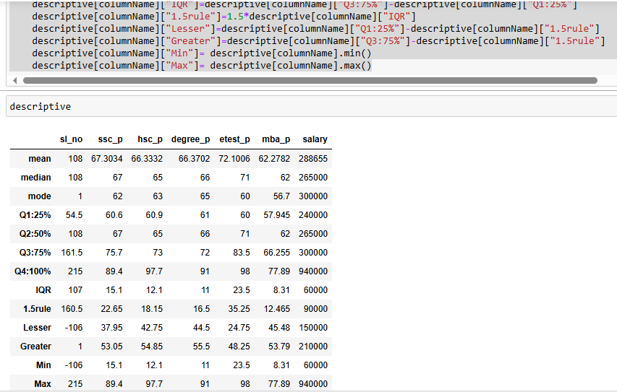

**Description:**

* **Interquartile Range (IQR):** The spread of the middle 50% of values. Example: **Salary IQR = 60,000**.
* Using **IQR** to detect outliers is called the **1.5** x **IQR rule**. Using this **rule**, we calculate the upper and lower bounds, which we can use to detect outliers.
* The upper bound is defined as the third quartile plus **1.5** times the **IQR**. The lower bound is defined as the first quartile minus **1.5** times the **IQR.**
* **Lesser & Greater Boundaries:** The calculated lower and upper thresholds beyond which values may be considered outliers.
* **Min & Max:** The minimum and maximum values observed in the dataset